Rhapsody Element Creator

Andy Lapping

Digital Technical Engagement

IBM Engineering Lifecycle Management

# Overview

The Rhapsody Element Creator is a customizable helper to provide a quick and easy way to add elements to a model by providing the user with a dashboard.

## How it Works

The helper starts by reading a csv file that it uses to populate its ‘dashboard’. The currently selected element in Rhapsody is then checked and the dashboard greys out unavailable buttons (based on owners and aggregates – see below).

If a button is pressed, then an element of that type is created and highlighted in the browser (and if it is a diagram the diagram is opened). The helper continuously monitors the current selection in Rhapsody and so after adding an element the available buttons may change based on the new selection. Automatically switching to a newly created element is an option in the Options menu however if you manually select something else in the browser this is still tracked by the helper (so you can keep the window open and add elements anywhere).

### Owners and Aggregates

If you have your own custom profile and you have defined the owners or aggregates properties, then these are checked by the helper to decide if an option should be available. If no such properties have been defined then the helper enables the button (this means that it will work for non-profiled elements such as basic UML). If the button is pressed and the element is illegal (such as adding a Use Case to a Statechart) then the error is trapped and a message presented in Rhapsody.

### Options:

The Options menu allows you to toggle Always on Top and also whether the Helper automatically navigates to an element upon creation (thereby changing the currently selected element)

These options are stored in a preferences file in your user directory (ElementCreator.ini)

## Example

Launching the Element Creator on a Project with a custom profile (in this case a Star Wars profile !) presents the following – all buttons are greyed out except for Equipment Configuration – the only element allowed at project level by this profile:

Clicking Equipment Configuration creates one and then switches to it – now further buttons are available:

Clicking AT-AT creates one and the buttons change again:

# Customizing

The supplied profile has a **PRP**, a **HEP** and two sample csv files: **Launch** **Element Creator** and **Launch Grid 2**

## HEP File

The **HEP** should be customized to allow Rhapsody to find the helper wherever you have installed it:

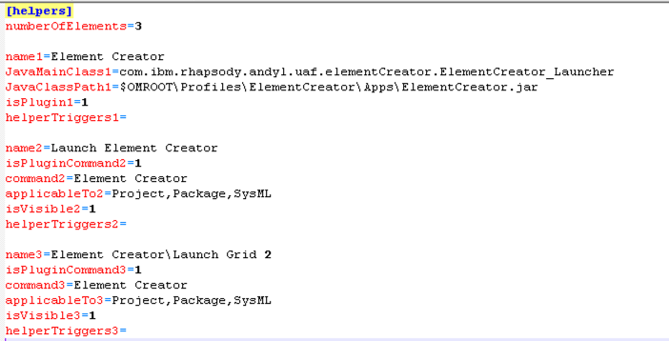

Note that multiple CSV files may be used. When the helper is launched, it first looks in the *BasePathForCustomCSVFiles* folder (see properties below) for a csv file with the same name as the menu entry in the hep file (only the menu name – the path to the menu name is discarded). If no file is found with that name then it instead looks for the csv file specified in the property (see below).

This allows multiple grids to be used and invoked from the browser rather than having one (potentially very large) grid.

## PRP File

The **PRP** file allows you to name the helper (the name appears in the header bar of the dashboard – the same name will be used regardless of which csv file is in use) and also to point at the default csv file to use. If the *LockOnSelectedElementAtLaunch* property is set to true, then new elements will always be added to the element that was selected when the helper was launched. If it is set to false, then new elements will always be added to the **current** selection (the current selection may change if the Navigate to Created Element option is selected in the UI)

To use your own

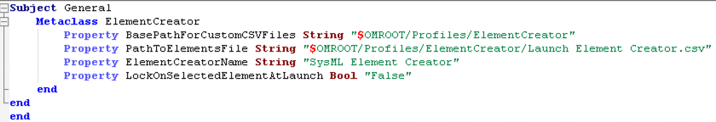

## Elements File

The CSV file(s) should be formatted as shown below to customize the content of the dashboard(s). The CSV file is read upon launch of the helper and so you can modify it freely without restarting Rhapsody or reloading the model – simply relaunch the helper after changes.

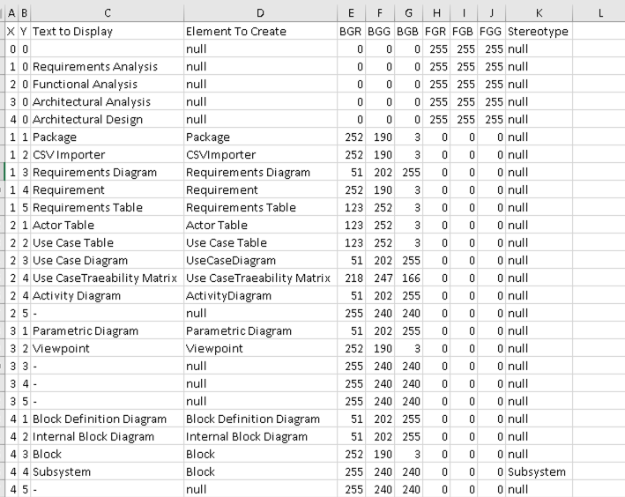

**X**: Row in Dashboard

**Y**: Column in Dashboard

**Text to Display**: The name that appears in the dashboard

**Element To Create**: The model element to create when the button is pushed (which can be base types or new terms). Note that Rhapsody sometimes uses different names in the API than in the display – for example to add a *Use Case Diagram* then the Element To Create field should read *UseCaseDiagram*

**BGR, BGG, BGB**: The RGB colour code for the background colour in the cell

**FGR, FGB, FGG**: The RGB colour code for the Foreground colour in the cell.

**Stereotype**: The stereotype to apply on the newly created element. All of the cells must have an entry - use the keyword *null* to specify no stereotype.

**Empty Cells**: You may either leave a cell empty (have no entry for it at all in the matrix) or you may add some text and set the Element to Create to null (this is a keyword that prevents the helper from creating a button at all). However, the table must be fully formed – that is if you have a row in the CSV file then each cell in the row must contain data.

# Conclusion

This is a flexible helper that I’ve used on many profiles including UAF:

